Click or tap here to enter text.

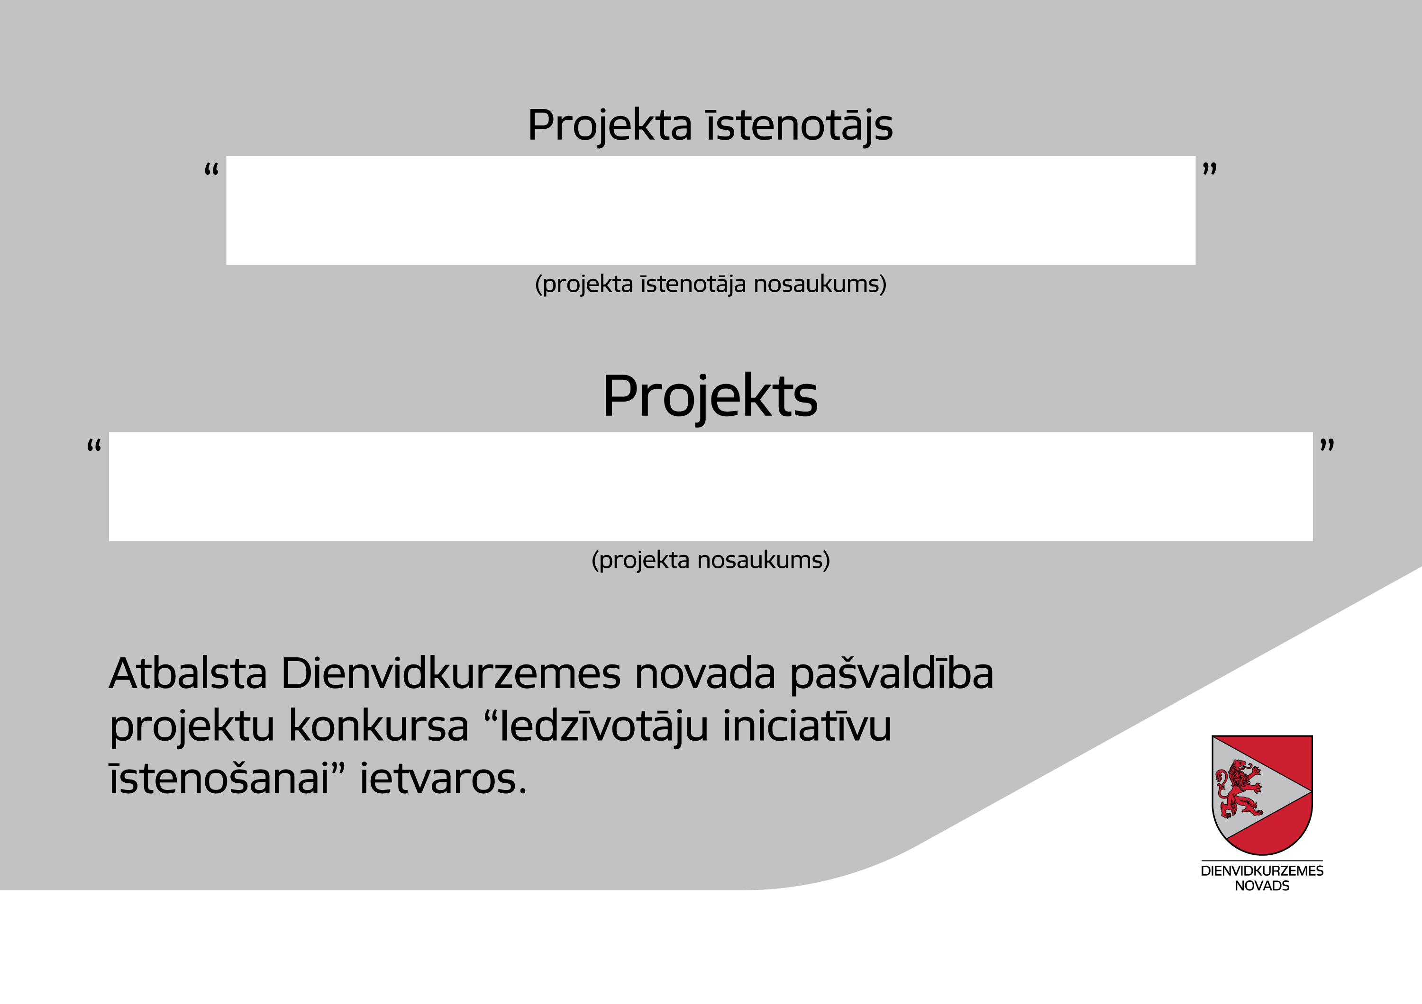 Click or tap here to enter text.